Security Newsletter
  - December 1, 2016

FOR an analytical and operational advantage |  | In This Issue

KGH Security Newsletter
by Joseph A. Gonzalez, FSO; Amanda Wilmore, Assistant FSO

Security News
As 2016 comes to a close, a review of the cybersecurity landscape, from the rise of ransomware to the alleged hacking of the presidential election, appears to indicate things cannot get much worse. According to CIO magazine online, however, 2017 threatens to be on par with, if not worse than, 2016. Read CIO’s “2017 Security Predictions” here.

Insider Threat Implementation
On May 18, 2016, the promulgated National Industrial Security Program Operating Manual (NISPOM) Change 2 required that all cleared contractors under the NISP must have an established Insider Threat Program by November 30, 2016.
This requirement also required the appointment of an Insider Threat Program Senior Official (ITPSO), implementation of workforce training requirements related to insider threat; and self-certification to the Defense Security Service.
Kiernan Group Holdings, Inc. has successfully fulfilled the requirements set forth by DSS by appointing an ITPSO and self-certifying to DSS.
See the attachment below to view KGH’s Insider Threat Program.
In 2017, the outstanding requirement of employee and consultant training will be disseminated to satisfy DSS requirements in full. Be on the lookout for annual training reminders, including Insider Threat training, in KGH’s January newsletter.

Miscellaneous Security Items of Interest
If you missed the “DSS 2016 Targeting U.S. Technologies” webinar, here is your chance to view it. The webinar is now archived here.
If you are embarking on foreign travel during the holidays (or any time throughout the year), you are required to read and complete a foreign travel briefing prior to traveling and a foreign travel debriefing upon your return. A DSS CI Foreign Travel Briefing short, available here, provides valuable information on how to increase your awareness of threats at your travel destination(s).
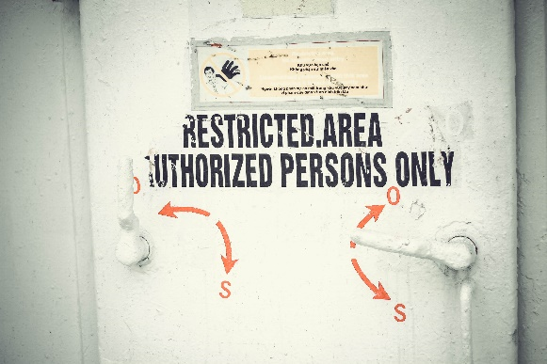
NISPOM Change 2 Implementation
For details regarding NISPOM Change 2 Implementation and how it affects you, click here.
Connect with the Center for Development of Security Excellence (CDSE)
For current news on security training, education, and certification, click the links below to follow CDSE on social media.
- Facebook
- Twitter
- YouTube

