Time Reporting Instructions

- Log into www.paychexflex.com:
- From the menu, select Time and Attendance – you will be taken to the following screen:

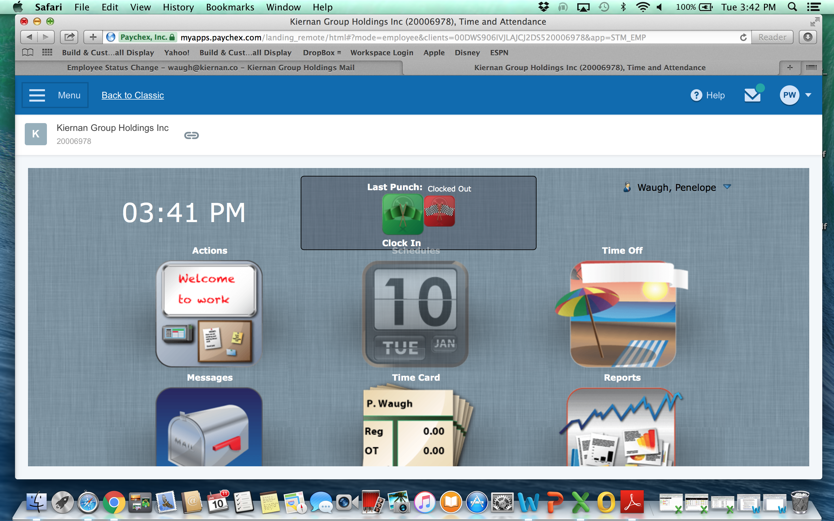
- Select the first folder titled Actions - you will be taken to the following screen:

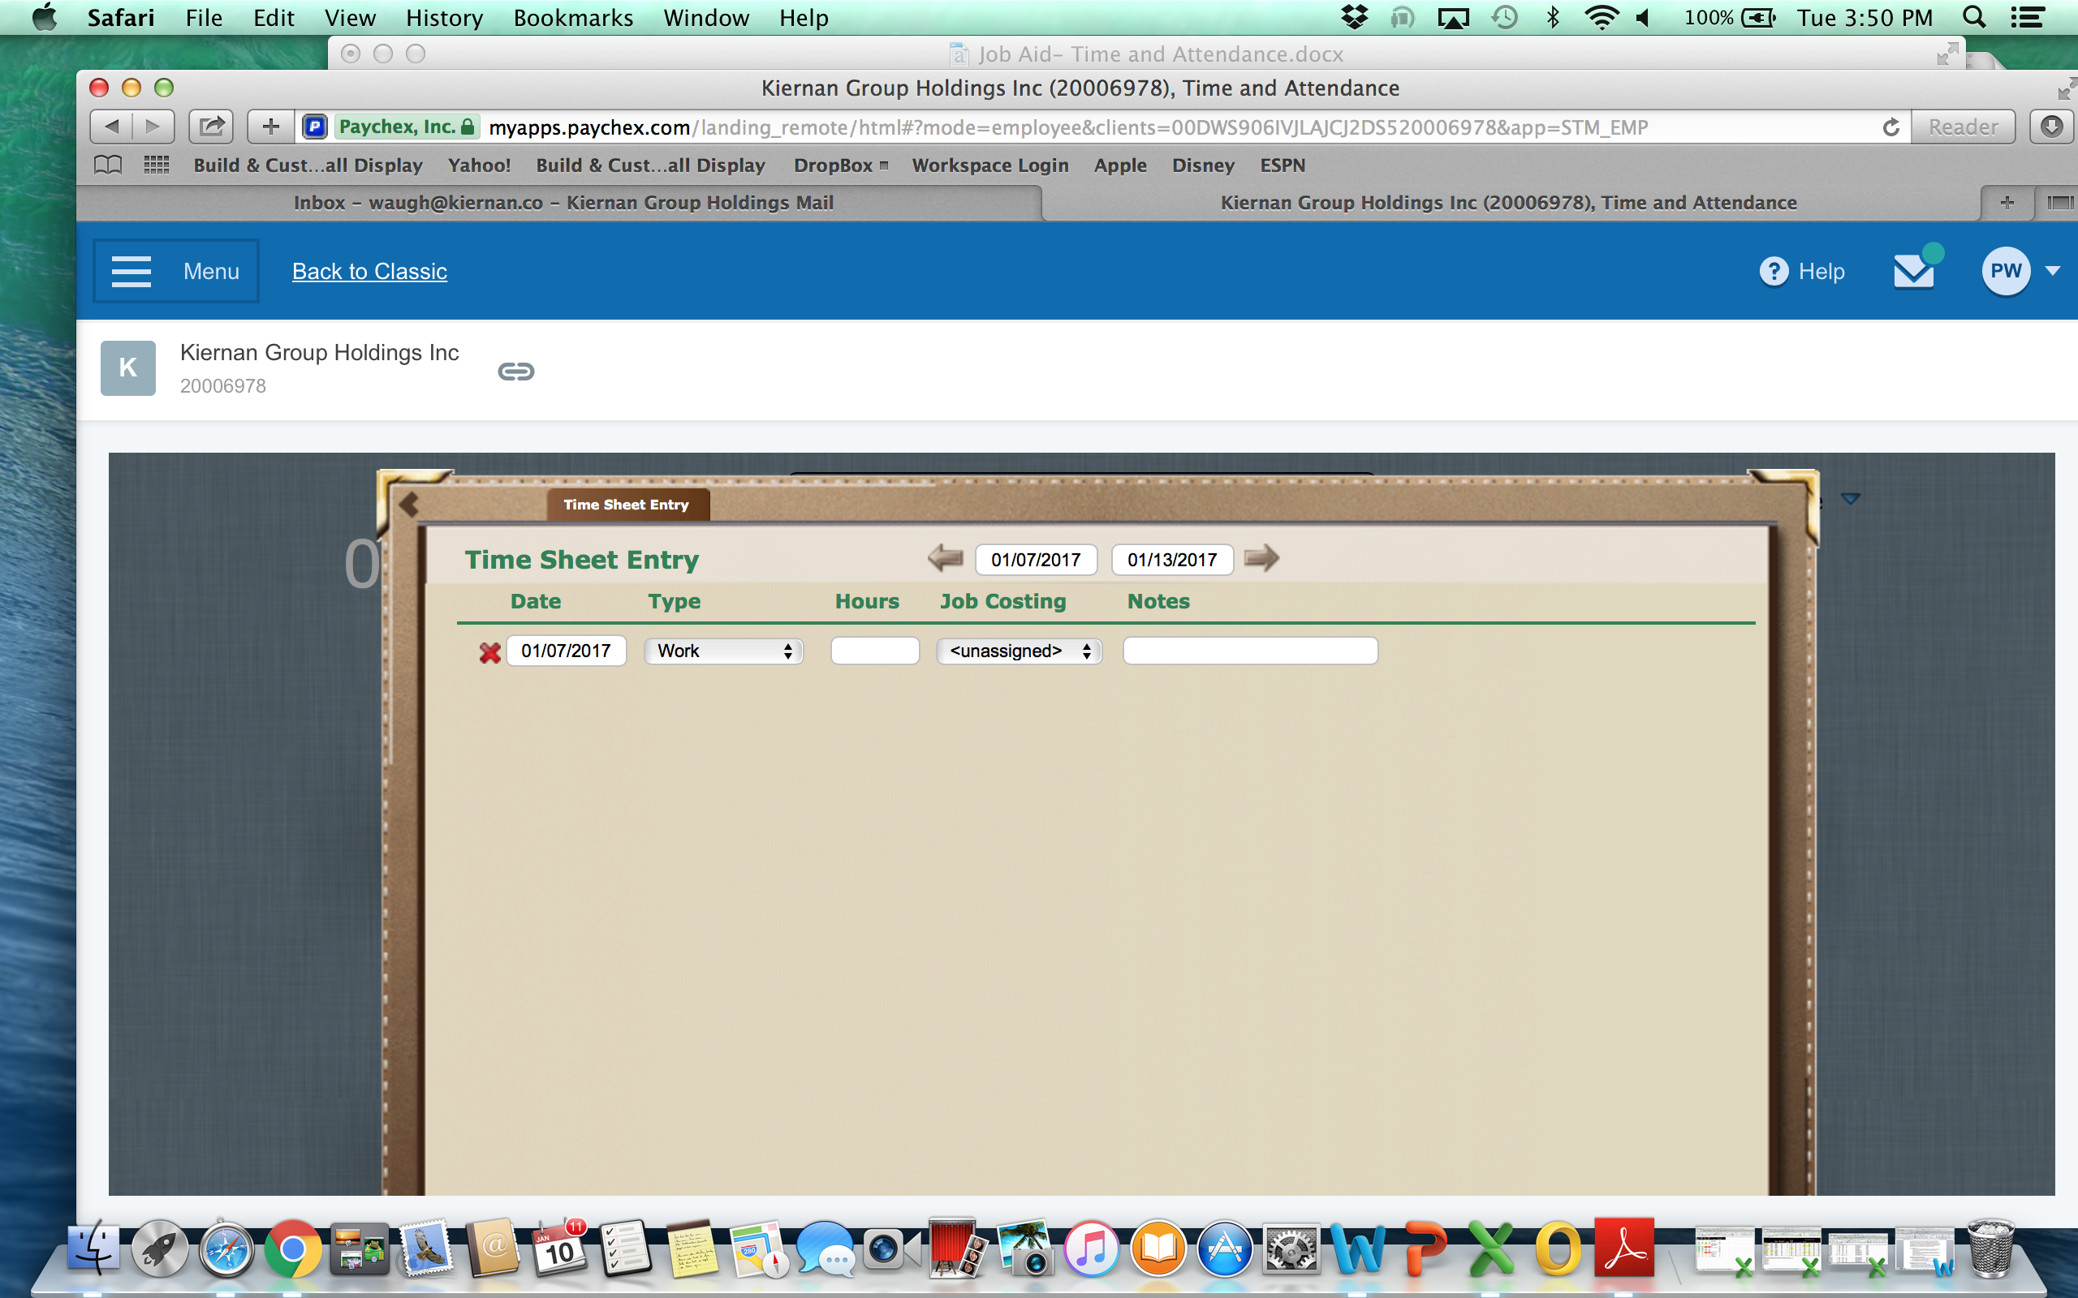

- Input Time
  - Select the workweek at the top of the page.
  - Select the workday.
  - Choose the pay type (work, holiday, PTO, LWOP/unpaid)
  - Add total hours for the project/task.
  - Select the project/task (alpha order)
  - To add another time sheet entry, select the plus sign in the lower left corner. Another row will pop up allowing you to add hours against another project/task.
  - Submit/Submit and Close. By taking this action, you attest that the data you have entered in correct to the best of your knowledge.

- Request Time Off
  - From the dashboard, select Time Off
  - Select the “time off” link found in the upper left hand corner.
  - Select leave type (PTO, LWOP).
  - Select dates you will be away from the office.
  - Complete notes section indicating reason for leave.
  - A Leave Request message will be sent to your manager.

