National Counterterrorism Workshop
November 5 – 7, 2014
The Lorien Hotel
1600 King Street
Alexandria, VA 22314 (703-894-3434)
This document is not releasable to the public. Please respect our integrity and your responsibility to protect from public release.

Wednesday, November 5, 2014 (Business Attire)
Reception
5:30 p.m. – 7:30 p.m.
Gadsby’s Tavern
138 N. Royal Street
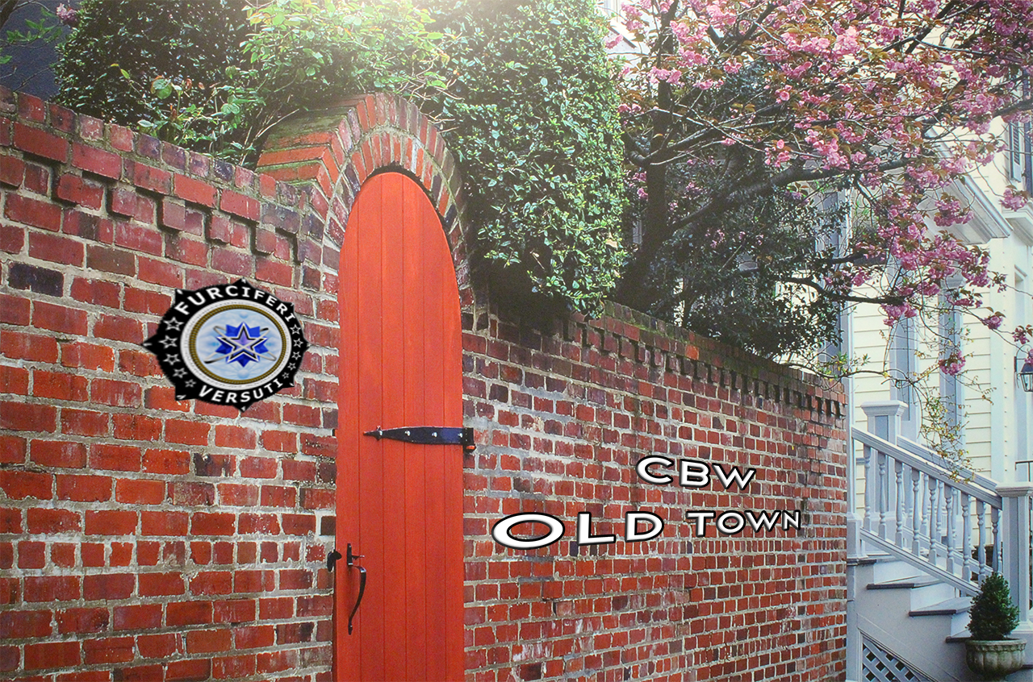
Alexandria, VA 22314

Thursday, November 6, 2014 (Business Attire)
Fuciferi Versuti Workshop – The Lorien Hotel
8:00 a.m. – 4:30 p.m.
Registration/Breakfast Begins at 7:15
Lunch Provided

Friday, November 7, 2014 (Business Attire)
Fuciferi Versuti Workshop – The Lorien Hotel
8:00 a.m. – 2:00p.m
Breakfast 7:15
Lunch Provided

Accommodations:
A block of rooms is reserved under “Kiernan Group Holdings (KGH)” for attendees at the Lorien Hotel. Please reserve your room by October 21, 2014.

Transportation:
Airport – the closest airport is Reagan National Airport
Ground transportation – The metro is very accessible from the airport to the Hotel. Please use the yellow/blue metro line from National Airport to the King Street Metro Station in Alexandria; the Lorien Hotel is a five-minute walk from the metro station. A short taxi ride from the airport to the hotel is also an alternative.
Parking:
- Parking is available at the Lorien Hotel for $32 a day.
- Another option is to park at the Embassy Suites Hotel on Diagonal Rd. (directly across from King Street Metro). Parking is $19/day and is then a five-minute walk to the Lorien Hotel. Exit the parking garage on Diagonal Rd. and take a right onto Diagonal Rd. Continue two blocks and take a right on King Street. The Lorien Hotel is 2 blocks up on the right.
Friendly Reminder:
You are responsible for booking/scheduling your own travel arrangements, but travelers outside of the Washington Metro Area will be reimbursed for non-refundable, economy-class airfare, taxis to and from the airport, lodging and meals within GSA per diem.For further information please contact Deborah Gunn at KGH at gunn@kiernan.co

