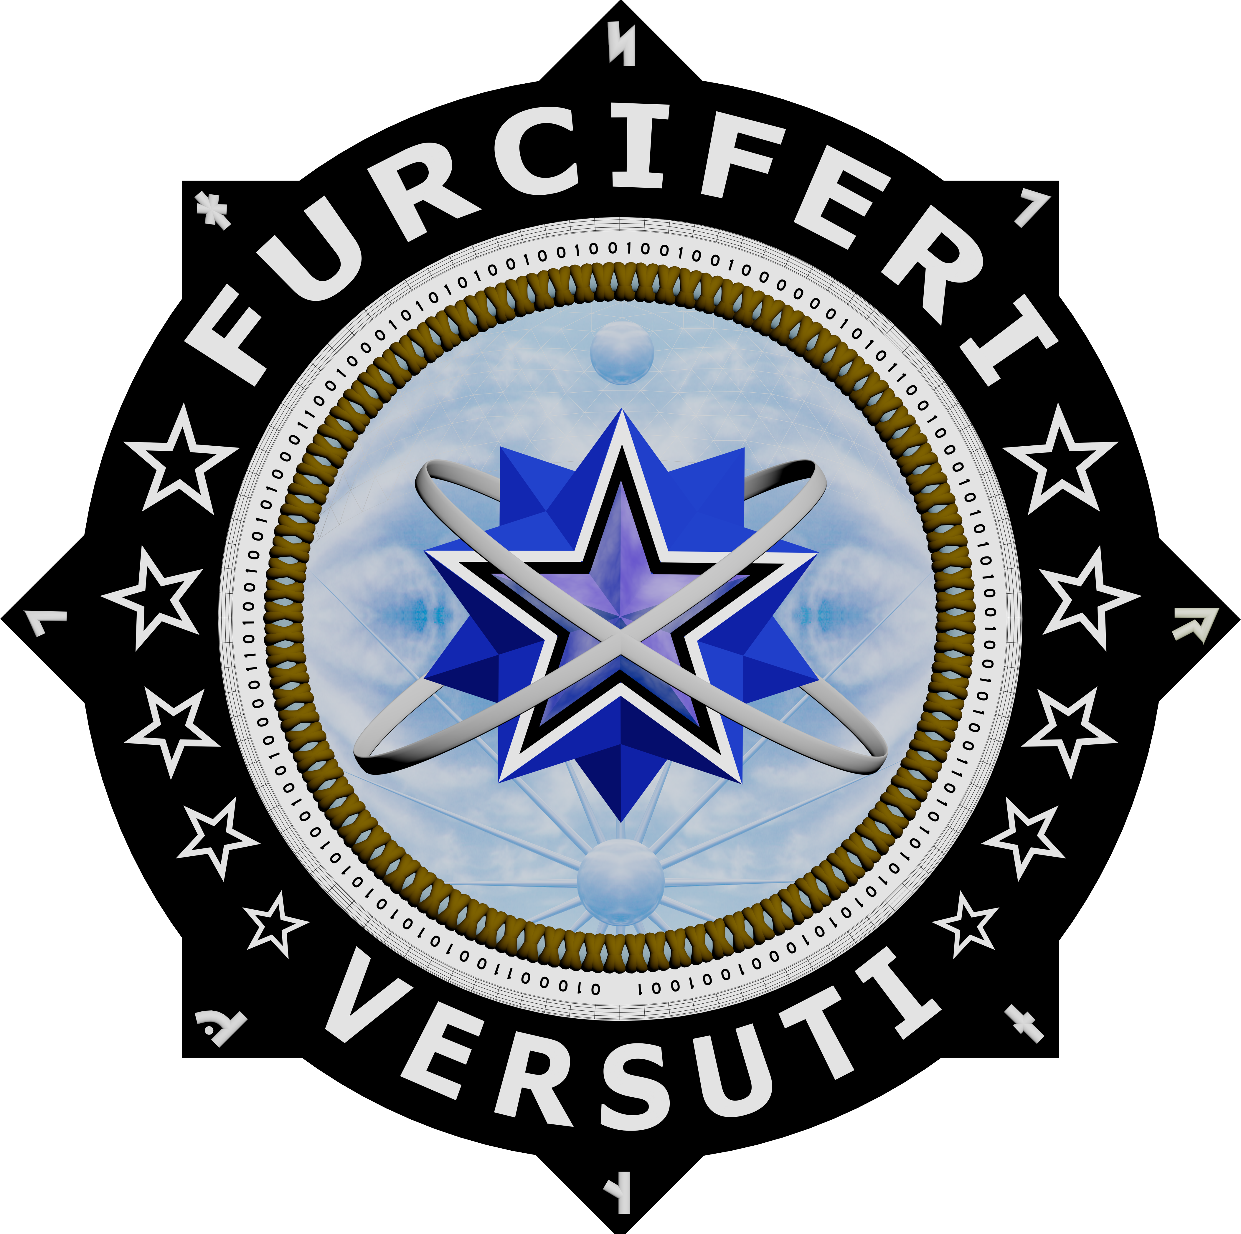

TM

Crafty Bastards Playbook

What is a Crafty Bastard?

“Here’s to the crazy ones. The misfits. The rebels. The troublemakers. The round pegs in the square holes. The ones who see things differently … Maybe they have to be crazy. How else can you stare at an empty canvas and see a work of art? Or sit in silence and hear a song that’s never been written? Or gaze at a red planet and see a laboratory on wheels? We make tools for these kinds of people. While some see them as the crazy ones, we see genius. Because the people who are crazy enough to think they can change the world, are the ones who do.”

- Steve Jobs

Crafty Bastards Workshops
Furciferi Versuti™, or Crafty Bastards, is a highly specialized analytical process exclusively created by Kiernan Group Holdings, Inc. (KGH) to provide multidisciplinary problem solving and custom tailored solutions for the world’s most complex current and emerging threats and challenges. This unique approach provides deep and broad ranging insights into the nature of the problem and allows the client to identify solutions to counter emerging and existing threats, which may not have otherwise been developed. Today’s threats are continually changing and increasingly complex, amplified when the enemy and their tactics are unknown. Potential and emerging threats can be seen in the blurred outlines of the proliferation of violent ideology and extremism, shifts in the global economy, intensifying regional resource constraints, increasing cyber-attacks, failed and failing states, and expanding global criminal networks, among others. Countering these threats and the complex problems that stem from them requires the development of novel solutions.

KGH’s Crafty Bastards Workshops (CBW) restructure these complex problems and identify opportunities for innovation by embracing the following tenets:

- Established organizational assessment processes do not inherently identify threats, challenges, or solutions, regardless of expert administration.
- Administrative and bureaucratic structures inhibit innovation, creating self-induced constraints in a battle against adversaries free of such constriction.
- Thinking faster than the “speed of threat” requires refinement of cognitive agility and the appetite for accepting divergent opinions and earned experience.

Scalable, agile, and adaptable to stakeholder needs and preferences, CBWs embrace the philosophies of disruptive learning to facilitate breakthroughs in thinking and enable participants to think like the Furciferi Versuti™. Participants in CBW develop innovative problem-solving skills and encounter exceptionally diverse combinations of talented, globally vetted Subject Matter Experts (SMEs). These SMEs represent eclectic communities and possess an ability to work flexibly and in detail with an array of non-kinetic strategic vectors, which help identify, redefine, and conquer emerging threats.

Central to the CBW is the assembly and leveraging of the talents of experienced practitioners from a broad range of public and private sectors to uncover and undermine the threats that may not have previously known to exist. This expertise illuminates dangers embedded in plain sight, differentiates adversaries from potential allies amid the chaos of broad social and political change, and expands the collective capacity to respond in the face of complex problems in more versatile, more creative, and timelier ways. This variety and depth of skills allows for the overlay of unique perspectives over the given problem set, while accounting for diverse cultures, context, and tactics in the analysis of the problems and development of solution. Through this engagement, participants become able to reframe the problems at hand. In summary, CBWs break down problem sets and learned thinking constraints to illuminate innovative solutions for exploitation.

Methodology
KGH has refined an eight-week process for a CBW, identifying necessary logistical and procedural tasks in addition to engagement with SMEs and pre-workshop analysis of the problem. It is through this process that the problem is framed, manipulated, and reconstructed in innovative ways. Key to this methodology is exploitation of multiple hypotheses concurrently to ensure that one particular perspective does not dominate the process and identification of all possible drivers and indicators of the problem are illuminated. The primary stakeholder remains engaged throughout the process. Depending on client requirements, the CBW approach can also be condensed from the standardized eight-week timeline, and the workshop structure can be adjusted to suit the client’s needs, ranging from the standard two-day workshop to a serious of smaller, four-hour workshops.

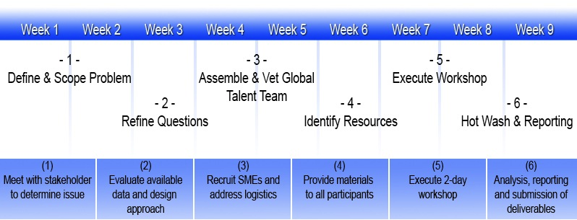

As highlighted in the timeline, the methodological process defines and scopes the problem, ensures KGH is asking the right questions, assembles the right team of global talent, identifies available resources, and provides pre-and post-workshop analysis and reporting. This includes conducting open-source and classified research, analysis of the specific problem set, defining the desired outcome, discussion of any preconceptions, bias, or constraints, and providing necessary pre-workshop reading material to participants to help frame the conversation. Upon conclusion of the workshop(s), final reporting is provided to the key stakeholder and formal out briefs are provided to identified communities.

Approaches
Crucial to this methodological process is the assessment of the problem set from multiple perspectives, which leads to the development of solutions along numerous strategic vectors. KGH’s proprietary process uses 18 strategic, non-kinetic, attack vectors that serve to open the number of possible interventions. The vectors are highlighted in the CBW Wheels, below.

The CBW process is neither about a single vector, nor, checking the box of all the vectors. Innovation comes from CBW participants confronting critical and complex choices and applying them to their problem set. Within the CBW framework, the initial question may be deconstructed and a previously overlooked relationship may be revealed, highlighting a new opportunity or solution.
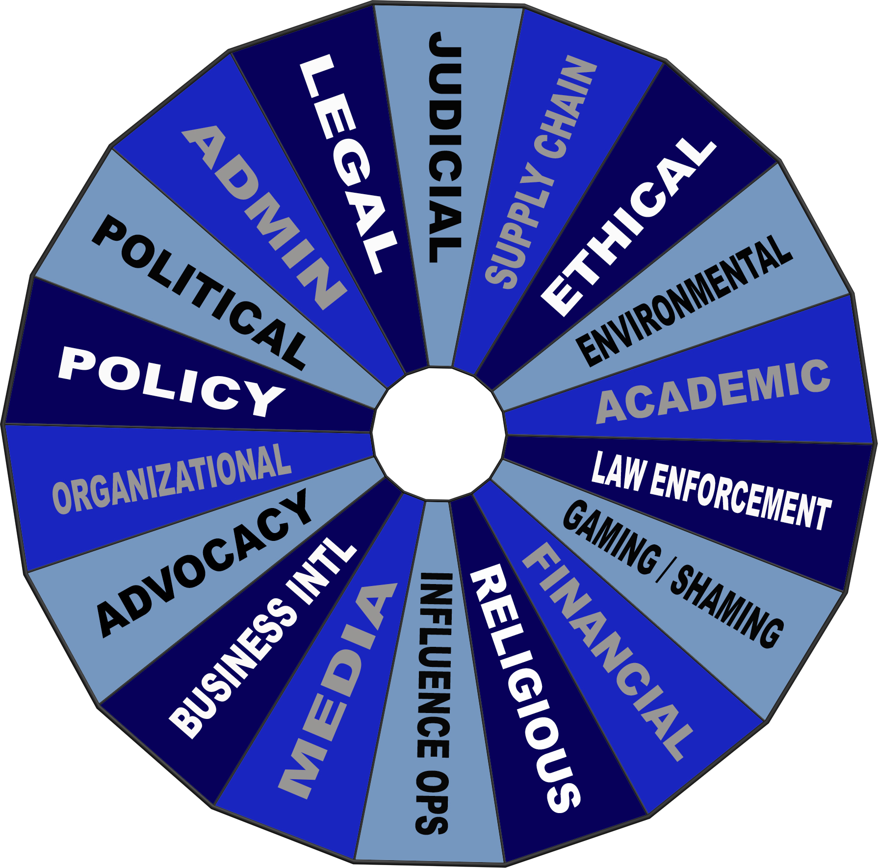

- Administrative
- Political
- Policy
- Organizational
- Advocacy
- Business Intelligence
- Media
- Influence Operations
- Religious
- Financial
- Gaming/Shaming
- Law Enforcement
- Academic
- Environmental
- Ethical
- Supply Cain
- Judicial
- Legal

Furciferi Digitale
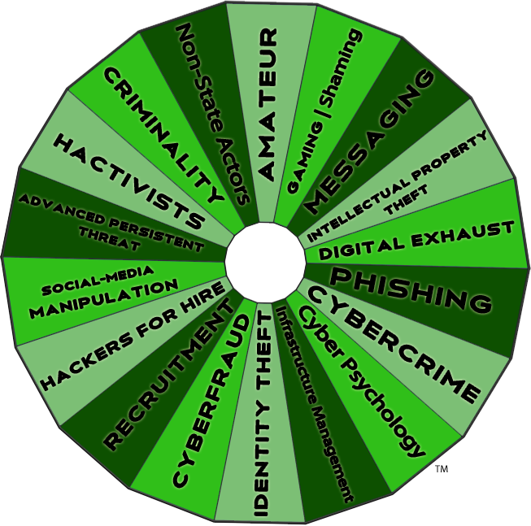
"Furciferi Versuti (Crafty Bastards™) is a component offering of its trademark workshop methodology that illuminates cyber dangers hidden in plain sight, often invisible to the untrained eye. This is the ungoverned space persistently exploited by criminals, state-sponsored actors, and others. Cyber Bastards applies its disruptive learning approach for government and private sector clients to exploit technological evolutions, disruptions, and the adversarial innovation process that impacts security, privacy, infrastructure protection, investment, and training. It is a methodology that illuminates and exploits complex problem sets at a visceral level through the blending of talented practitioners from across multiple and diverse fields of experience.

- Identity Theft
- Cyberfraud
- Recruitment
- Cybercrime
- Hackers for Hire
- Social-Media Manipulation
- Advanced Persistent Threat
- Hactivists
- Criminality
- Non-State Actors
- Amateur
- Infrastructure Management
- Gaming & Shaming
- Messaging
- Intellectual Property Theft
- Digital Exhaust
- Phishing
- Cyber Psychology

Deliverables
KGH provides the following for a CBW:
- Exhaustive Literature Review
- Tailored Learning Environment
- Brilliance on Demand
- Facilitated Workshop
- Proceedings, Finalized Report, and Out-Brief

Literature Review
KGH researches existing open-source and/or classified literature to develop a baseline understanding of information regarding the problem set. Relevant and/or interesting articles are aggregated for participants and stakeholders in the learning environment.

Tailored Learning Environment
KGH’s online Learning Environment is a secure portal that catalyzes engagement with the problem set, offers workshop preparation materials, provides a forum for discussion and continuously engages the participants throughout the CBW process, which encourages the continued exchange of new ideas in a forum that is adaptive and dynamic.

Brilliance on Demand
KGH provides access to a diverse group of SMEs who are adept at deconstructing and reevaluating complexity. The CBW process blends different disciplines, and perspectives to produce a unique environment that systematically fights organizational complacency and reveals problems hidden beneath the surface.

Facilitated Workshop
Enables participants to engage in disruptive learning, develop and demonstrate the cognitive agility to identify alternative approaches.

Proceedings, Finalized Report, and Out-Brief
KGH provides stakeholders with a formal report of CBW proceedings, actionable opportunities discussed, and strategic recommendations.

Furciferi Versuti: The Name and Logo
Latin works very differently from English, and terms of abuse rarely correspond in a simple word-for-word way. “Bastard” in Latin, irrespective of which of the two above words you use, simply means a person whose parents are not married, and nothing else; and, to translate a phrase like 'crafty bastards' one has to translate the sense, not the individual words.

- 'Furcifer', which literally means 'one who carries his own yoke', that is, 'gallows rogue', 'hang dog', ‘rascal' and the like, is used in Roman drama to mean exactly what we mean by the word 'bastard'.
- For crafty we have ‘versuti’ which means adroit, dexterous, versatile, shrewd, clever, ingenious, wily and cunning.
This gives: Furciferi Versuti…Crafty Bastard.

There are ten stars on the side of the logo (five per side).
- Ten is the base of the decimal numeral system, by far the most common system of denoting numbers in both spoken and written language. Ten is the first two-digit number in decimal and thus the lowest number where the position of a numeral affects its value. Any integer written in the decimal system can be multiplied by ten by adding a zero to the end (e.g. 855 x 10 = 8550). The reason for the choice of ten is assumed to be that humans have ten fingers (digits).
- Ten is a centered triangular number or a centered figurate number that represents a triangle with a dot in the center and all other dots surrounding the center in successive triangular layers. The centered triangular number for n is given by the formula (3n^2 + 3n + 2)/2.
- Ten-codes are commonly used on emergency service radio systems.
- Ten is the number of space-time dimensions in most superstring theories.
- The Ten Commandments of Exodus and Deuteronomy are considered a cornerstone of Judaism and Christianity.
- In music theory ten is the interval of a major, or minor tenth is an octave plus a major or minor third.
- Increasing a quantity by one order of magnitude is most widely understood to mean multiplying the quantity by ten.

There are 16 rays on the orb at the bottom of the logo.
- 16 is a centered pentagonal number.
- 16 is the base of the hexadecimal number system, which is used extensively in computer science.
- There are 16 geomantic figures that are primary symbols used in the art of divinatory geomancy. Each geomantic figure represents a certain state of the world or the mind and can be interpreted in various ways based upon the query put forth and the method used to generate the figures.
- 16 is the only number of the form xy=yx with x and y different integers.
- 16 is the maximum number of regions into which space can be divided by four spheres.

There are two orbs and two orbital ribbons in the logo - representing the sun and the earth / the earth and the moon / and a binary star system.
- Two is the smallest and the first prime number and the only even one (for this reason it is sometimes called ‘the oddest prime’).
- Two is the number of polynucleotide strands in a DNA double helix.
- The most common philosophical dichotomy is perhaps the one of good and evil, or the process of synthesis creates two perspectives from one.
- Powers of two are central to the concept of Mersenne primes and important to computer science. Two is the first Mersenne prime exponent.
- The two orbital ribbons also represent atomic rotational structure as well as CLASP security.
  - Comprehensive Lightweight Application Security Process (CLASP) is an activity-driven, role based set of process components guided by formalized best practices. CLASP is designed to help software development teams build security into the early stages of existing and new-start software development life cycles in a structured, repeatable, and measurable way. CLASP is based on extensive field work in which the system resources of many development life cycles were decomposed to create a comprehensive set of security requirements. These resulting requirements form the basis of CLASP's Best Practices, which can enable organizations to systematically address vulnerabilities that, if exploited, can result in the failure of basic security services (e.g., confidentiality, authentication, and authorization).

There are eight points around the logo.
- A byte is eight bits.
- Eight is the base of the octal number system, which is mostly used with computers. In octal, one digit represents three bits. In modern computers, a byte is a grouping of eight bits, also called an octet.
- The number eight is a Fibonacci number, being three plus five.
- Eight is the only positive Fibonacci number, aside from one, that is a perfect cube.
- A cube has eight vertices.
- Sphenic numbers always have exactly eight divisors.
- Eight is the dimension of the octonions and is the highest possible dimension of normed division algebra.
- In nuclear physics, eight is the second magic number.
- In particle physics, the eightfold way is used to classify sub-atomic particles.
- In statistical mechanics, the eight-vertex model has eight possible configurations of arrows at each vertex.
- An octave, the interval between two notes with the same letter name (where one has double the frequency of the other), is so called because there are eight notes between the two on a standard major or minor diatonic scale, including the notes themselves and without chromatic deviation. The ecclesiastical modes are ascending diatonic musical scales of eight notes or tones comprising an octave.

There is a cloud in the background of the logo representing cloud computing and ethereal contrast.

The binary code around the logo spells "Furciferi Versuti".

The Medieval Runes on each triangle point spell "Strength.”

Kiernan Group Holdings, Inc. (KGH) is a woman-owned small business and is a customer focused, global, law enforcement and national security consulting firm that provides tailored solutions to today’s most complex challenges. For more information visit Kiernan.co.

