Analytic Spotlight: Promoting the Factors Leading to Reporting Suspicious Activities
By Analytic Team, Kiernan Group Holdings (KGH)
It is generally accepted that violent attacks can be prevented, as stated by the Department of Homeland Security (DHS), through “prompt and detailed reporting of suspicious activities” by such individuals to a local police department. This is part of DHS’s trademarked national campaign of “If You See Something, Say Something” that raises public awareness of the pre-incident warning indicators of imminent politically-motivated terrorism and related attacks such as by psychologically-motivated active shooters. This process of reporting such pre-incidnet suspicious activities is considered one of the most effective means of preempting potential attacks because local police departments are generally trained to respond quickly to such suspicious activity reports (SARs). As explained by DHS, once law enforcement officers assess the situation, they can either interview the suspect(s) in person or obtain additional support for such individuals, if necessary, from other relevant agencies, such as mental health organizations.
Significant Incidents of Not Reporting Suspicions About Violent Attackers
Below are examples of significant cases of violent rampages by individuals who had demonstrated early warning signs of potential engagement in violence, but despite the awareness of such high-risk indicators by people associated with them, such suspicious mindsets and activities were not reported to local law enforcement authorities for early preemption.
- November 5, 2009: Nidal Hasan, 47, a U.S. Army major and psychiatrist, fatally shot 13 people and injured more than 30 others a mass shooting at his base in Fort Hood, near Killeen, Texas. Hasan is reported to have exhibited numerous worrisome changes of behavior that should have raised red flags while he was employed from around December 2008 to May 2009 as a psychiatrist at Walter Reed Army Medical Center, in Washington, Although Hasan was deemed barely competent as a practicing psychiatrist by his colleagues and supervisors, over issues such as his delivery of presentations that focused on jihadi issues, he was not removed from his job because of the cumbersome and lengthy process for expelling physicians, involving hearings and potential legal challenges. It was also decided that his upcoming deployment in July 2009 at Fort Hood, in Killeen, Texas, would enable additional psychiatrists and other mental health specialists to monitor his concerning behavior and take corrective action, if necessary.
- July 20, 2012: James Holmes, 25, carried out a mass shooting at the Century movie theater, in Aurora, CO, killing 12 and injuring 70 others. He had been a doctoral student in neuroscience at the University of Colorado Denver, and had been seen by several campus mental health practitioners, including a psychiatrist, who was monitoring his deteriorating mental state, and to whom he had reportedly informed that he was contemplating killing people, although he did not specify any individuals or methods to carry out his attack. Although his psychiatrist had reportedly passed on her concerns to campus security, Holmes dropped out of his graduate program, but no one outside of the university was warned about his deteriorating mental state and potential violent intentions.
- September 27, 2012: Andrew Engeldinger, 36, carried out a shooting rampage at the Accent Signage Systems company, outside of Minneapolis, MN. Six people were killed, and two others injured. Engeldinger had been an employee at the company since 1999, but on the day of the shooting he was informed that he was about to be fired. Throughout his employment, he had been repeatedly disciplined “for offensive behavior, tardiness and poor job performance.” His family had been aware of his mental illness, but he had refused their offers to help him get treatment.
- December 2, 2015: Syed Rizwan Farook, 28, and his wife, Tashfeen Malik, 27, conducted a shooting rampage at the husband’s office’s holiday party at the Inland Regional Center, in San Bernardino, CA, killing 14 people and injuring 22 others. Neighbors of the couple, who lived in nearby Redlands, had reported afterwards that they had seen them “acting suspiciously in recent weeks” working late at night in their house’s garage and receiving numerous packages that appeared out of place. However, they did not report their suspicions “for fear of racial profiling.”
Assessment
The examples above are highlighted because it is necessary to understand why suspicions about their potentially violent intentions were not reported, which is discussed in the first part of this section. The second part discusses what needs to be done to redress this problem because the consequences of not managing it effectively is costly not only in terms of loss of lives of those targeted by them, but legal and financial liabilities to those who do not exercise due diligence in providing safe work environments for their employees.
Part One: Why Suspicious Indicators May Not Be Reported
Despite the guideline of “seeing something, saying something,” however, there are several factors that make it complicated to report suspicious behaviors by risk-prone individuals to the appropriate authorities. These include the following:
Federal Legal Regulations. First, under the Health Insurance Portability and Accountability Act’s (HIPAA) Privacy Rule regarding the use/disclosure of an individual’s personal health information (PHI) (which also includes one’s mental health), there are demarcated boundaries on the use or disclosure of such health records, with violators accountable with civil or criminal penalties for violating the privacy of an individual’s PHI.
Second, under the Family Educational Rights and Privacy Act (FERPA), the privacy of students’ educational records, including disciplinary records, is protected. Nevertheless, they may be disclosed without a student’s consent “To comply with a judicial order or lawfully issued subpoena” or in a case of “health or safety emergency in order to protect the student or others.”
In a related factor, and one that applies to the case of James Holmes, with such patients with mental health problems being evaluated by psychologists, it is still difficult for them to assess their potential risk of violence. This is due to the fact that if a patient does not have a history of prior violent activity, an accurate assessment of the likelihood of future violence is difficult. Nevertheless, with the biggest risk for violence is access to or ownership of a firearm, in the absence of evidence that a patient is in the process of acquiring weapons, it is difficult to predict such trajectory into violence.
Even if a psychologist finds sufficient risk indicators to report them to appropriate authorities, another hurdle is the legality of the confidentiality of such therapy sessions. Thus, to what extent are psychologists obligated to report their suspicions about a patient? An exception may include a strong concern that a patient is on the verge of posing an imminent danger to himself or to others.
Group Decision Making. In the discipline of social psychology, according a March 25, 2016 article by Kevin Dutton and Dominic Abrams on the theory of group inhibition of bystander intervention in emergencies, published in “Scientific American,” such crises usually begin as “ambiguous, potentially innocuous situations.” If group members who might also be confronted by such emergencies decide not to act, individuals within that group will also decide not to take action. Thus, individuals tend to reference others for taking action, or, in this case, not taking action, since they are part of the overall group dynamics that may be playing out. In the case of neighbors becoming aware of someone’s “out of the ordinary” suspicious activities, they may not take action because others in the neighborhood are not intervening.
Other related group decision making factors in not contacting authorities might include being uncomfortable about judging others, including engaging in racial or ethnic profiling; concern they might get an innocent person in trouble with the law; and concern about possible retaliation by the individual they have placed under suspicion.
Part Two: The Path Forward
As demonstrated by these selected cases and the constraints and inhibitors that need to be overcome, when something suspicious is encountered, as DHS explains, that “shouldn’t be there – or someone’s behavior…doesn’t seem quite right,” it is important to “say something.” Despite the obstacles discussed in Part One, it is crucial to come up with solutions to strengthen engagement by individuals, whether in organizations or in neighborhoods, to report suspicious mindsets and behaviors that might lead to violent action.
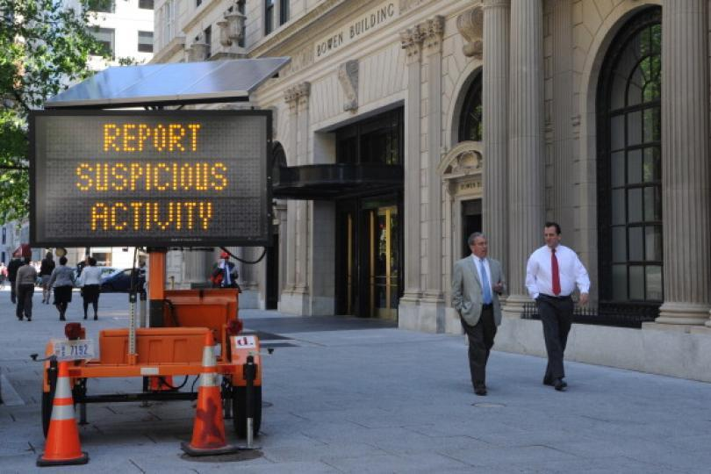
Photo: Stephane Jourdain/AFP/Getty Images
First, it is required, under federal guidelines, for employers to be proactive in managing individuals of concern, as they are mandated by the Department of Labor’s Occupational, Safety and Agency’s (OSHA) General Duty Clause to provide their employees a safe workplace free from recognized hazards that can cause death or serious injury. This includes a “hazard identification, hazard mitigation, hazard control” response to an aggressive intruder or active shooter who intend to do harm to people in work settings. The general duty clause requires employers to take steps to minimize these hazards. These mitigation steps include providing training on how to recognize indicators of potential active shooters as well as how to respond when an active shooter situation exists. If training is not provided, it could potentially result in the finding of an OSHA Act violation, thereby opening the door for a civil liability against the business.
Second, as demonstrated by the consequences of Engeldinger’s violent rampage, his company was found liable in a court judgement for being negligent in not properly adhering to OSHA’s “General Duty Clause” by implementing security precautions, resulting in an undisclosed financial settlement with the family of one of his victims.
Finally, the links in the chain of the psychologically-driven group dynamics that might inhibit people to take action can be broken, according to the article by Dutton and Abrams, through interpersonal empowerment’s “sense that we are all responsible for outcomes that affect other people’s well-being, in addition to our own. Simple interventions include poster campaigns on public transportation showing, perhaps, a suspicious bag and the warning: ‘Don’t leave it up to others. It’s YOUR call!’”

